1. Tables: aisle access
   1. Draw a sketch of the area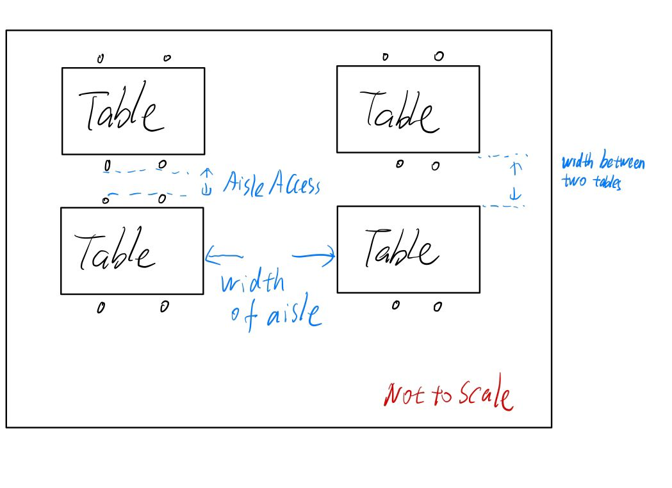
   2. What is the measured width between two tables?
      1. 27.78in
   3. What is the width of the aisle access?
      1. 27.78-19=8.78in
   4. What is the code required width (Cite the code)?
      1. 13.2.5.6.7 The requirement of 13.2.5.6.6 shall not apply to those portions of aisle accessways where the required width, not including the seat space described by 13.2.5.9.3, does not exceed 12 in. (305 mm).
      2. 13.2.5.9.3* Where nonfixed seating is located between a table and an aisle accessway or aisle, the measurement of required clear width of the aisle accessway or aisle shall be made to a line 19 in. (485 mm), measured perpendicularly to the edge of the table, away from the edge of said table.
2. Tables: aisles
   1. Reserved
   2. What is the measured width between the two tables?
      1. 62.37in
   3. What is the width of the aisle?
      1. 62.37in
   4. What is the code required width (Cite the code)?

**13.2.5.10.2\*** The width of aisles serving seating at tables shall be not less than 44 in. (1120 mm) where serving an occupant load exceeding 50, and 36 in. (915 mm) where serving an occupant load of 50 or fewer.

1. Stacks
   1. Draw a sketch of the area图示

      描述已自动生成
   2. What is the measured width between the stacks?
   3. What is the code required width (Cite the code)?
      1. IBC 2018. Table 1607.1

b. The loading applies to stack room floors that support nonmobile, double faced library book stacks, subject to the following limitations:

1. The nominal book stack unit height shall not exceed 90 inches.

2. The nominal shelf depth shall not exceed 12 inches for each face.

3. Parallel rows of double-faced book stacks shall be separated by aisles not less than 36 inches wide.

1. Theater style classroom
   1. Draw a sketch of the area图示, 工程绘图

      描述已自动生成
   2. What is the occupant load of the room? (Note: the posted occupant load is not telling you what you think it means). Show your work.

218 fixed seats (included the platform)

Area in front of the classroom: 18 ft x 30 ft/7(ft2^person) which is less than 218

So the occupant load of the theater style classroom

* 1. How many exits are required?

Two exits are required.

* 1. What is the measured width of each exit? Draw a sketch of how you measured. 43 in + door leaf 2 in =**45 inches**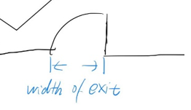
  2. What is the required width of each exit?

218/2=100->101 persons per exit.

109*0.2=21.8 in

The required width of each exit is 21.8 inches.

* 1. What is the measured width of the aisle access? Draw a sketch of how you measured.

22.5in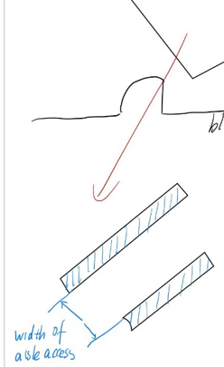

* 1. What is the code required width of the aisle access (Cite the code)?

**13.2.5.7.2** The aisle accessway between rows of seating shall have a clear width of **not less than 12 in**. (305 mm), and this minimum shall be increased as a function of row length in accordance with 13.2.5.7.4, 13.2.5.7.5, and 13.2.5.7.6.

**13.2.5.7.5.1** The 12 in. (305 mm) minimum clear width of aisle accessway specified in 13.2.5.7.2 shall be increased by 0.3 in. (7.6 mm) for every seat over a total of 14 but **shall not be required to exceed 22 in**. (560 mm).

* 1. What is the measured width of the aisle? Draw a sketch of how you measured.

63in

* 1. What is the code required width of the aisle (Cite the code)?

**13.2.5.8.3\*** Minimum Aisle Width. The minimum clear width of aisles shall be sufficient to provide egress capacity in accordance with 13.2.3.1 but shall be not less than the following:

**(4)** 42 in. (1065 mm) for level or ramped aisles having seating on both sides, except that the minimum clear width shall be not less than 30 in. (760 mm) for catchment areas having not more than 60 seats

1. Bench
   1. Draw a sketch of the area文本

      描述已自动生成
   2. What is the measured length of the bench?

185.1 in

* 1. What is the occupant load?

4 section, 8 rows bench for each section, the length of each bench is 185.1 in

The occupant load is 185.1/18= 10.28 ->10 persons

10*8*4=**320 persons**

